Input

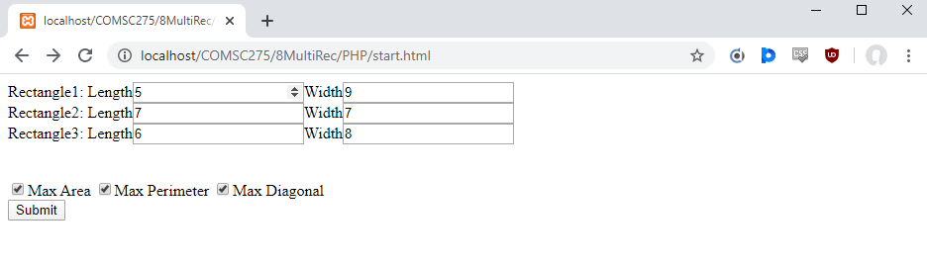

Output

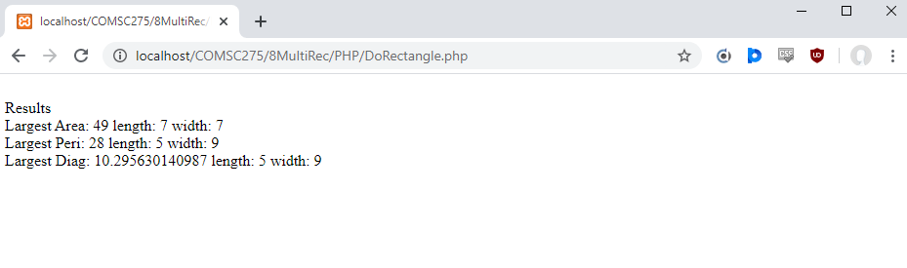Start.html

<!DOCTYPE html>

<html>

<head>

</head>

<body>

<form action="DoRectangle.php" method = "post">

Rectangle1: Length<input type="number" name="len1">Width<input type="number" name="wid1"> <br>

Rectangle2: Length<input type="number" name="len2">Width<input type="number" name="wid2"> <br>

Rectangle3: Length<input type="number" name="len3">Width<input type="number" name="wid3"> <br><br><br>

<input type="checkbox" name="op[]" value="area" checked="true">Max Area

<input type="checkbox" name="op[]" value="perim">Max Perimeter

<input type="checkbox" name="op[]" value="diag">Max Diagonal <br>

<input type="submit" name="submit" value="Submit"><br><br>

</form>

</body>

</html>

Rectangle.php

<?php

class Rectangle {

private $length;

private $width;

public function __construct ($length, $width) {

$this->length=$length;

$this->width=$width;

}

public function __get ($name) {

switch ($name) {

case "length":

return $this->length;

break;

case "width":

return $this->width;

break;

}

}

public function findArea(){

$area = $this->length * $this->width;

return $area;

}

public function findPerim(){

$perim = 2 * ($this->length) + 2 * ($this->width);

return $perim;

}

public function findDiag(){

$power = pow($this->length, 2) + pow($this->width, 2);

$diag = sqrt($power);

return $diag;

}

//If need be, function __set ($name,$value) method can be written similarly

//In this assignment, we don’t need this method

}

?>

DoRectangle.php

<?php

require 'Rectangle.php';

$len1 = $_REQUEST['len1'];

$wid1 = $_REQUEST['wid1'];

$len2 = $_REQUEST['len2'];

$wid2 = $_REQUEST['wid2'];

$len3 = $_REQUEST['len3'];

$wid3 = $_REQUEST['wid3'];

$op = $_POST['op'];

$rec1 = new Rectangle($len1, $wid1);

$rec2 = new Rectangle($len2, $wid2);

$rec3 = new Rectangle($len3, $wid3);

$rec = [$rec1, $rec2, $rec3];

print <<< Results

<br>Results<br>

Results;

if(in_array("area", $op)){

$list = [$rec1->findArea(), $rec2->findArea(), $rec3->findArea()];

$max = max($list);

$key = array_search($max, $list);

$recT = $rec[$key];

$length = $recT->__get("length");

$width = $recT->__get("width");

print <<< Here

Largest Area: $max length: $length width: $width<br>

Here;

}

if(in_array("perim", $op)){

$list = [$rec1->findPerim(), $rec2->findPerim(), $rec3->findPerim()];

$max = max($list);

$key = array_search($max, $list);

$recT = $rec[$key];

$length = $recT->__get("length");

$width = $recT->__get("width");

print <<< Here

Largest Peri: $max length: $length width: $width<br>

Here;

}

if(in_array("diag", $op)){

$list = [$rec1->findDiag(), $rec2->findDiag(), $rec3->findDiag()];

$max = max($list);

$key = array_search($max, $list);

$recT = $rec[$key];

$length = $recT->__get("length");

$width = $recT->__get("width");

print <<< Here

Largest Diag: $max length: $length width: $width<br>

Here;

}

?>